**SI206 Final Report**

My Goals

My goals for this project were to create an output visual map that plotted all the latitude and longitude points of my Facebook friend’s recent posts. This would allow me to see the locations of my Facebook friends at the time they posted their last Facebook post. I also wanted to connect the Dark Sky and Google Maps API to my program to find the current weather conditions of a Friend’s hometown, as listed on their Facebook account, and find places geographically close to the user’s current location. My goal for this project was to first get it to work for myself, and then I figured I would be able to easily loop through the project to apply my code to many different Facebook users.

The Goals I Achieved

Of the goals I set forth for myself, I was able to complete the first stage of my project by applying this code to my own personal Facebook information. I could successfully create an output graph that plotted the geographical coordinates of my hometown on a visual map using mat.lib. This process took a long time to figure out, as there were many toolkits that I needed to download prior to completing this task. I was also able to obtain a Dark Sky API key that got a large amount of current weather information about an input set of latitudinal and longitudinal points. I could find the user’s hometown on Facebook, use his or her hometown’s name to search Google Maps to see the latitude and longitude for that location, and then use dark skies to find the weather at these coordinates.

Problems I faced

I encountered a variety of challenges while I worked on this final project. First, I could only obtain access to my own posts. When I tried to load posts made by my friends, I was only able to fetch 10 of their posts using the API. There were several different permissions required for me to have access to even my Facebook Friend’s profiles. Because of these restrictions, I was unable to reliably pull hometown information from the 10 friends the Facebook API would let me search. As a result, I focused on using my own posts and profile information, for this project, as I had all of the permissions to fetch it. The code could grow to accommodate more users, however, I will first need to obtain permissions from the Facebook Developers to do so. Furthermore, to protect my Facebook friend’s data, my current code contains an inactive Facebook API key, and I instead cached all of the data needed to run my program into various .json files.

Social Media Report

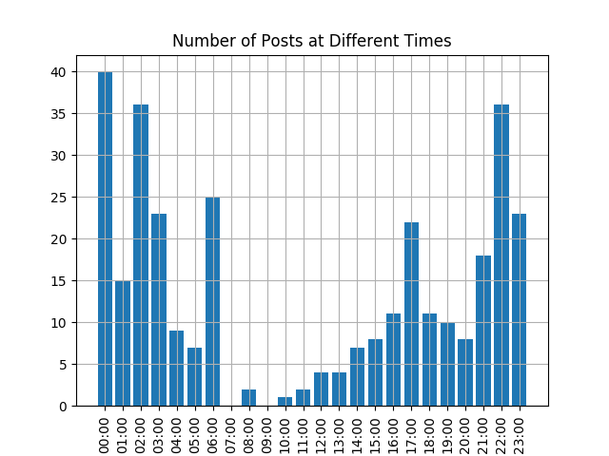

This graph above represents all the posts I have ever made on Facebook. The y axis represents post density, while the x axis represents time of day. Based on this graph, I was most active on Facebook at 10pm, 12am, and 2am. Furthermore, I have never posted on Facebook at 7am or 9am. It’s interesting to see how I have barely used social media between 7 am and 5pm, however right before I go to bed, I appear to be the most active.

Instructions for Running Code

1. First, you will need to import all of the following modules:
   * Import os
   * import json
   * import googlemaps
   * import facebook
     + Facebook imported in zipped file
   * import requests
   * import sqlite3
   * from datetime import datetime
   * import io
   * import dateutil.parser
     + $sudo pip3 install python-dateutil
   * import numpy as np #for time frequency analysis
     + $sudo pip3 install numpy
   * import pandas as pd #refer to slides from class
     + $sudo pip3 install pandas
   * import matplotlib.pyplot as plt
     + $ sudo ip3 install matplotlib
2. The python file you want to run in terminal is called final_project.py
   * $python3 final_project.py
3. You will then be prompted to input user input. The user’s data that you will be searching through is my personal Facebook information that has been cached into this zip file
   * Options will look like this:

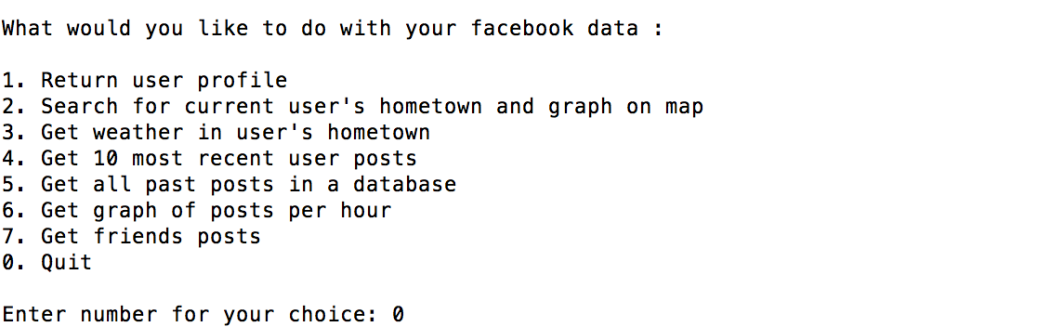

1. You can enter the number’s 1-7 and 0 to quit. The program will continue to run until 0 is entered.
2. All of the above options can be run using the cached file in the zipped file I submitted.
3. Descriptions of each function can be found commented in the final_project.py file

Documentation for each resource used:

*Refer to following table

|  |  |  |  |
| --- | --- | --- | --- |
| **Date** | **Issue Description** | **Location of Resource** | **Result**  **(did it solve the issue?** |
| 11/29 | Connecting to Facebook API | http://facebook-sdk.readthedocs.io/en/latest/api.html | Helped get me the basic connection for me to build on |
| 12/2 | Connecting to Dark Sky API – error with Lat/Long | https://darksky.net/dev/docs | Yes, figured out how to properly format lat/long |
| 12/6 | Creating a visual map to pot up | https://matplotlib.org/users/beginner.html | Tried to use plotly but was having trouble. Ended up reading the mat.lib documentation to download the mat.lib toolkit. I then was able to use the example code they provided to figure out how to alter parts of the map like color, lat/long map marker, and map detail. |
| 12/13 | Was getting a mat.lib error while running my program in terminal | https://stackoverflow.com/questions/24502500/python-matplotlib-getting-rid-of-matplotlib-mpl-warning | Inserted a line of code to ignore the warnings in the future. |
| 12/13 | Getting date into a format that could be graphed | https://docs.python.org/3/library/argparse.html | Yes, I imported the dateutil.parser to my file |